**HTTP5204 : EXERCISE 1**

**ERD diagarams:-**

Task 1 (Planning) : Create an ERD (entity relationship diagram) reflecting the relationships between the core concepts. Looking for (1-Many, Many-Many, and 1-1 Relationships)

Answer:-

I have included the diagrams below.In the figure 1(a), i have included the one to many relationships.The pets and species have one to many relationship as to a species , many pets can belong.That suggests that in the pets table, we will be having the foreign key referencing to the species table and that one is speciesid.In the database, there can be many pets of one species like many of the one species.

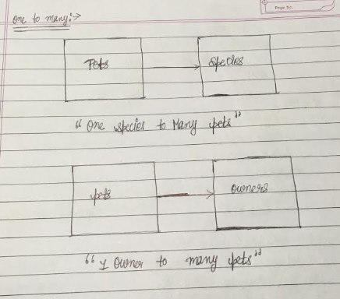

Figure-1(a)

Now moving to pets and owners, one owner can have many pets assuming that it is allowed for our system.That leads to 1 owner to many pets relationship.If that will not be allowed i.e. one owner can have only one pet then that will become a one to one relationship.Otherwise, it 1 owner to many pets relatioship as one owner will be allowed to have more than one pets.

Now, from figure1(b).I have included here many to many relationships that can exist in our system.The owners and groomers can have many to many relationship as one owner can have many groomers for the grooming of his/her pet like if he wants to get nail-trimming from one groomer and shampooing from other.

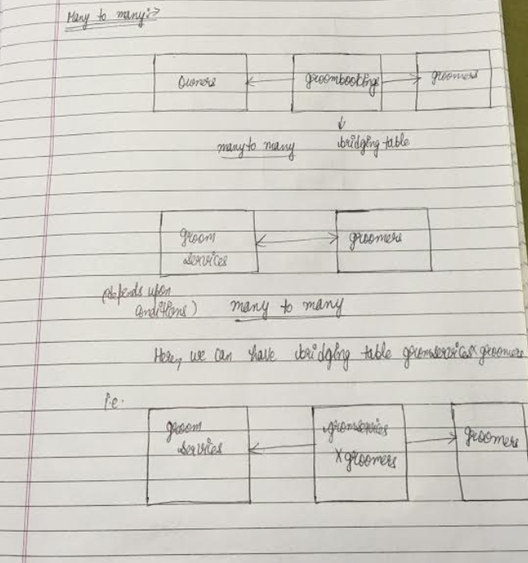

Figure:1(b)

So, one owner can have many groomers for the service of his/her pet.So, one one owner can have many geoomers for his pet assuming that it is allowed in our system if the owner is not forced to have only groomer for his/her pet.Now, groomer can have many owners as his customers.As, he/she will not be working for one owner .He/she will be giving service to a lot of people.So, one grooomer to many owners relation is true.

So, the relationship is true from both side for owners to groomers and is many to many.Now, many to many relationships always have a bridging table.In this case, groombookings act as a bridging table as groombookings associate goomers and owners with each other for a booking.In the groombooking table, there will be two foreign keys ownerid and groomerid.That are required for a groobooking as booking can only be done between a groomer and an owner.If an ownerr will be apponiting more than one groomers than that owner will need to make diffrent bookings assuming one booking can only be done between a groomer and an owner.So, the owner will need to make diffrent appointments for the diffrent groomers as the groomers may be available on different times or many other conditions may act that make our system act like that.Also, in the groombookings table, one foregin key will be ownerid and other will be groomerid.So, it will not make any sense to have two groomersid’s for one booking.

So, the owners and the groomers table have many to many relationship with bridging table groombookings that acts like a bridge between them..

From figure 1(b) again, other many to many relationship is between the groomservices and the groomers.It depends upon conditions.Let us assume that one groomer can give many groomservices.So, one groomer to many groomservices is true.And it is becomes one groomer to many groomservices relationship.Now reverse, one groomservice can be done by many groomservices according to our assumption.So, the relationship between groomservices and the groomers is many to many.Because, one groomer can give many groomservices and one groomservice can be done by many groomers.Like one groomer can give many groomservices like nail-cuting and shampooing.So, we can have a bridging table between the two tables let us assume, that one is groomservicesxgroomers table that will be having two foreign keys groomserviceid and the groomerid.That will be linkig our two tables together.If our assumption will not be there then this relationship will not be working for our system.So, this is condition depending relationship.

Now one to one relationships,from figure 1(c) .

**These relationships that i am giving are true from one side.But, from other side these do not make any sense.So, these are not true.But, i am justifying them why these are not true.**

These one to one relationships are not true.I am just suggesting that someone can think of.but, actually these are not true.I am justifying this below.

Firslty, one groombooking can be associated only to one groomer as according to our assumption if the owner will be hiring more than one groomers then he/she will have to make diffrent bookings for that.So, one groombooking can have only one groomer associtaed with it.And, it is also obivous for a groombooking to have one groomer who will be doing a grooming .So, a groombooking is always associated with a groomer.But from other side one groomer can have many groombookings from owners.That is why from other side it is not true.So, it does not make any sense to consider it one to one relationship.Because from other side it is not true.

Now, one groombooking can be associated with one pet only.As, for a booking one pet is necessary.For more than one pets, diffrent booking will be done assuming that in our system as diffrent pets will need diffrent appoimtments with a groomer depending upon time with the groomer in a case if a owner is having two pets or with diffrent groomers..So, a groombooking must refer a pet that makes it a one to one relationship.But, the pet on other hand may or may not have always booking associated with it.So, it is not one to one relationship from other side.

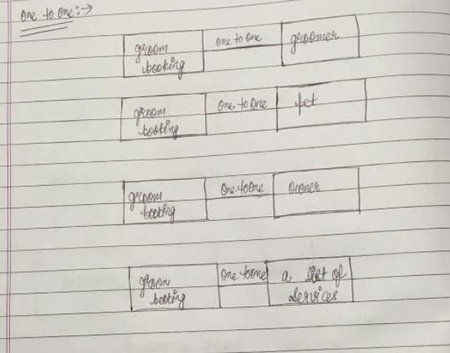

Figure-1(c)

Also, one groombooking must refer to an owner.It is very much clear from our system and according to our assumption that one owner can make one booking for his/her pet.So, groombooking to owner is a one to one relationship.Also, without owner there wil be no booking so owner is must for a booking.And, one groombooking can have one only one owner associated with it as groombooking table will be using foreign key ownerid and it will not be making any sense to have two ownerid’s in the one table.But, from other side, the owner may or may not be associated with a booking.So, it does not make any sense to consider it as a one to one relationship.

Finally, a groombooking must refer to a list of services.As, a groombooking is made only for the groomservices by an owner.So, that are necessary for a groombooking.In this case, the groombooking will be having a list of services that will be done by the partiicular groomer associated with that booking.While, from other side a list of services may or may not be associated with a booking.It is not compulsory for them to always associate with a booking.So, it is not a one to one relationship.